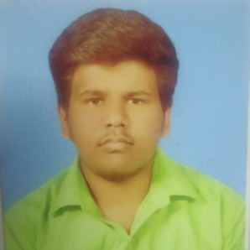

CAREER OBJECTIVE

D.SANJAY

No:176/66 ,Big Sourashtra Street, Thiruvappur, Pudukkottai-622003

8072314268 / 7708567525

[sanjaydev](mailto:sanjaydevadas99@gmail.com)[adas99@gmail.com](mailto:adas99@gmail.com)

[https://www.linkedin.com/in/sanjay-d-a9332b18a](https://www.linkedin.com/in/sanjay-d-a9332b18a" \o "https://www.linkedin.com/in/sanjay-d-a9332b18a)

To obtain a position that will enable me to use my strong organizational skills, educational background, and ability to work well with people.

EDUCATION

# Saranathan College Of Engineering

B.E Computer Science and Engineering 7.57

2020

# St. Marys Boys Higher Secondary School

HSC

88.25%

2016

# Municipal High School

SSLC 93.6%

2014

TECHNICAL SKILLS

C

Python Html

Css

Java basics

Javascript and angular basics Database-Mysql basics

PROJECTS

# BPO SYSTEM

BPO system can be developed using html, css, mysql and javascript. The main purpose of our project is contracting a speciﬁc work process to an external provider. The services can include payroll, accounting, telemarketing, data recording, customer support and more.

ACHIEVEMENTS & AWARDS

Completed Diploma Course in Computer Application. I have completed Java certifcation in oracleacademy.

PERSONAL PROFILE

DateofBirth : 27-02-1999

Nationality : Indian

Known Languages : English, Tamil , Sourashtra

Hobby : Listening music , Playing cricket

INTERESTS

Machine learning Data mining

PERSONAL STRENGTHS

* Creative and Logical
* Co-operative
* keen observer
* Quick learner

DECLARATION

I hereby declare that above information is correct to the best of my knowledge and belief.

Date :25-07-2020

Place : Pudukkottai



# D. SANJAY